Nguyễn đức phát 1150080152

Lớp: THMT

Bài tập lần 2

I. THỰC HÀNH

1. LinearLayout

Code khởi tạo LinearLayout:

package com.example.demo_app;  
import android.annotation.SuppressLint;  
import android.os.Bundle;  
import android.widget.LinearLayout;  
import android.widget.TextView;  
import android.view.ViewGroup;  
import android.view.Gravity;  
  
import androidx.appcompat.app.AppCompatActivity;  
  
public class MainActivity extends AppCompatActivity {  
  
 private LinearLayout llNameContainer, llAddressContainer, llParentContainer;  
  
 @Override  
 protected void onCreate(Bundle savedInstanceState) {  
 super.onCreate(savedInstanceState);  
  
 // Gọi các phương thức để tạo layout  
 createNameContainer();  
 createAddressContainer();  
 createParentContainer();  
  
 // Hiển thị layout cha lên màn hình  
 if (llParentContainer != null) {  
 setContentView(llParentContainer);  
 }  
 }  
  
 @SuppressLint("SetTextI18n")  
 private void createNameContainer() {  
 // Tạo LinearLayout cho tên, có hướng ngang  
 llNameContainer = new LinearLayout(this);  
 llNameContainer.setLayoutParams(new ViewGroup.LayoutParams(  
 ViewGroup.LayoutParams.MATCH_PARENT,  
 ViewGroup.LayoutParams.WRAP_CONTENT));  
 llNameContainer.setOrientation(LinearLayout.HORIZONTAL);  
 llNameContainer.setGravity(Gravity.CENTER_VERTICAL);  
  
 // Tạo TextView "Name:"  
 TextView tvNameLabel = new TextView(this);  
 tvNameLabel.setText("Name:");  
  
 // Tạo TextView chứa tên  
 TextView tvNameValue = new TextView(this);  
 tvNameValue.setText("nguyễn đức phát");  
  
 // Thêm TextView vào LinearLayout con  
 llNameContainer.addView(tvNameLabel);  
 llNameContainer.addView(tvNameValue);  
 }  
  
 @SuppressLint("SetTextI18n")  
 private void createAddressContainer() {  
 // Tạo LinearLayout cho địa chỉ, có hướng ngang  
 llAddressContainer = new LinearLayout(this);  
 llAddressContainer.setLayoutParams(new ViewGroup.LayoutParams(  
 ViewGroup.LayoutParams.MATCH_PARENT,  
 ViewGroup.LayoutParams.WRAP_CONTENT));  
 llAddressContainer.setOrientation(LinearLayout.HORIZONTAL);  
 llAddressContainer.setGravity(Gravity.CENTER_VERTICAL);  
  
 // Tạo TextView "Address:"  
 TextView tvAddressLabel = new TextView(this);  
 tvAddressLabel.setText("Address:");  
  
 // Tạo TextView chứa địa chỉ  
 TextView tvAddressValue = new TextView(this);  
 tvAddressValue.setText("236 Đ. Lê Văn Sỹ, Phường 1, Tân Bình, Hồ Chí Minh");  
  
 // Thêm TextView vào LinearLayout con  
 llAddressContainer.addView(tvAddressLabel);  
 llAddressContainer.addView(tvAddressValue);  
 }  
  
 private void createParentContainer() {  
 // Tạo LinearLayout cha, có hướng dọc  
 llParentContainer = new LinearLayout(this);  
 llParentContainer.setLayoutParams(new ViewGroup.LayoutParams(  
 ViewGroup.LayoutParams.MATCH_PARENT,  
 ViewGroup.LayoutParams.MATCH_PARENT));  
 llParentContainer.setOrientation(LinearLayout.VERTICAL);  
  
 // Thêm các LinearLayout con vào LinearLayout cha  
 if (llNameContainer != null && llAddressContainer != null) {  
 llParentContainer.addView(llNameContainer);  
 llParentContainer.addView(llAddressContainer);  
 }  
 }  
}

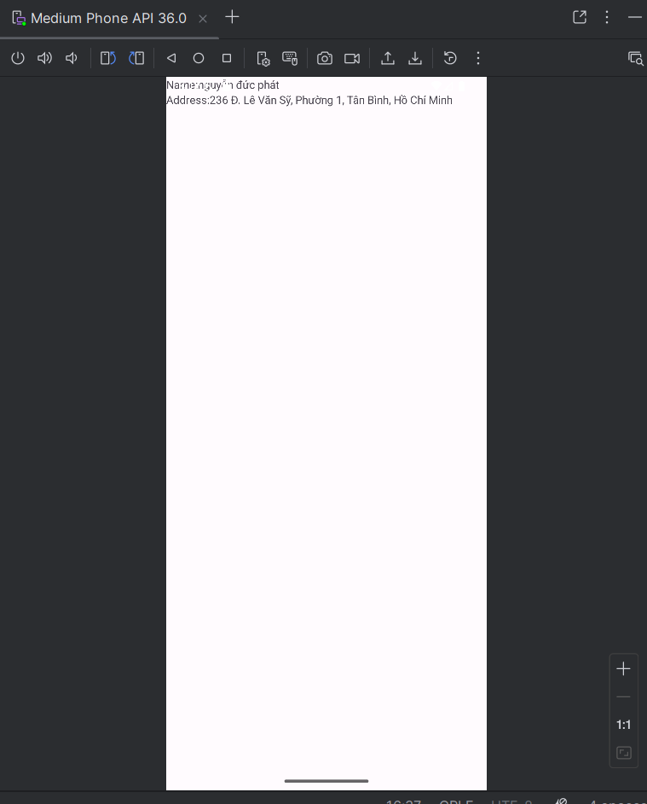

Hình ảnh: kết quả

1. Sử dụng LinearLayout trong file xml
2. Code file colors.xml

<?xml version="1.0" encoding="utf-8"?>  
<resources>  
 <color name="color0">#000000</color>  
 <color name="color1">#FF0000</color>  
 <color name="color2">#00FF00</color>  
 <color name="color3">#0000FF</color>  
 <color name="color4">#FFFF00</color>  
 <color name="color5">#FF00FF</color>  
 <color name="color6">#00FFFF</color>  
 <color name="color7">#FFFFFF</color>  
</resources>

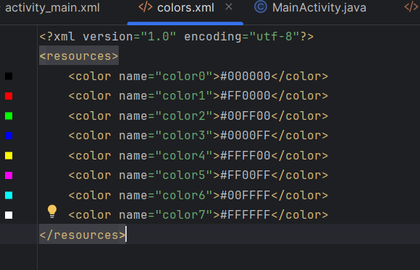

1. Sửa đổi file layout XML

Code:

<?xml version="1.0" encoding="utf-8"?>

<LinearLayout xmlns:android="http://schemas.android.com/apk/res/android"

xmlns:tools="http://schemas.android.com/tools"

android:layout_width="match_parent"

android:layout_height="match_parent"

android:orientation="vertical"

tools:context=".MainActivity">

<LinearLayout

android:layout_width="match_parent"

android:layout_height="0dp"

android:layout_weight="1"

android:background="@color/color0"

android:orientation="horizontal">

</LinearLayout>

<LinearLayout

android:layout_width="match_parent"

android:layout_height="0dp"

android:layout_weight="2"

android:orientation="horizontal">

<LinearLayout

android:layout_width="0dp"

android:layout_height="match_parent"

android:layout_weight="1"

android:orientation="vertical">

<LinearLayout

android:layout_width="match_parent"

android:layout_height="0dp"

android:layout_weight="1"

android:background="@color/color6"

android:orientation="horizontal">

</LinearLayout>

<LinearLayout

android:layout_width="match_parent"

android:layout_height="0dp"

android:layout_weight="1"

android:background="@color/color7"

android:orientation="horizontal">

</LinearLayout>

<LinearLayout

android:layout_width="match_parent"

android:layout_height="0dp"

android:layout_weight="2"

android:background="@color/color3"

android:orientation="horizontal">

</LinearLayout>

</LinearLayout>

<LinearLayout

android:layout_width="0dp"

android:layout_height="match_parent"

android:layout_weight="1"

android:orientation="vertical">

<LinearLayout

android:layout_width="match_parent"

android:layout_height="0dp"

android:layout_weight="1"

android:background="@color/color5"

android:orientation="horizontal">

</LinearLayout>

</LinearLayout>

<LinearLayout

android:layout_width="0dp"

android:layout_height="match_parent"

android:layout_weight="2"

android:background="@color/color1"

android:orientation="vertical">

</LinearLayout>

</LinearLayout>

</LinearLayout>

C . RelativeLayout

Code file strings.xml:

<**resources**>

 <**string name="app_name"**>Lab01_2c</**string**>

 <**string name="sign_in"**>Sign in</**string**>

 <**string name="username"**>Username: </**string**>

 <**string name="password"**>Password: </**string**>

 <**string name="signup"**>Sign up</**string**>

</**resources**>

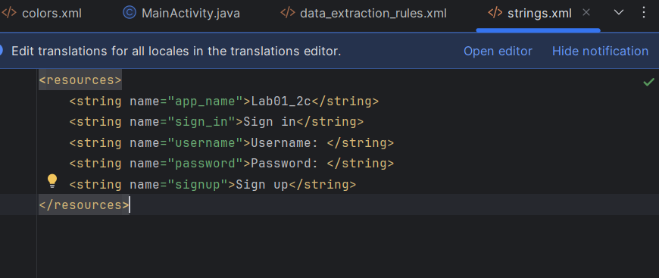

Code  dimens.xml

<**resources**>

*<!-- Default screen margins, per the Android Design guidelines. -->* <**dimen name="activity_horizontal_margin"**>16dp</**dimen**>

 <**dimen name="activity_vertical_margin"**>16dp</**dimen**>

 <**dimen name="margin_base"**>5dp</**dimen**>

 <**dimen name="margin_basex2"**>10dp</**dimen**>

 <**dimen name="margin_basex3"**>15dp</**dimen**>

 <**dimen name="margin_basex4"**>20dp</**dimen**>

 <**dimen name="text_small"**>16sp</**dimen**>

 <**dimen name="text_medium"**>18sp</**dimen**>

 <**dimen name="text_large"**>20sp</**dimen**>

</**resources**>

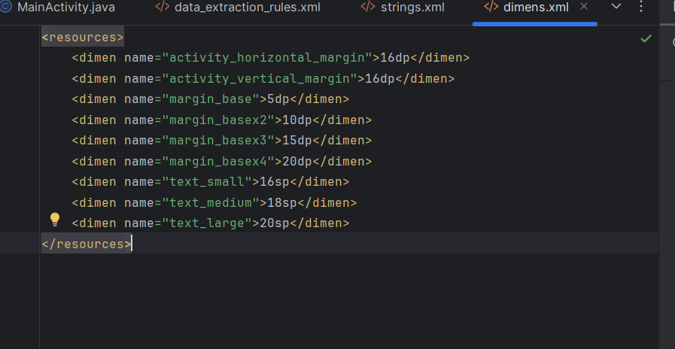

Code file activity_main.xml

<?xml version="1.0" encoding="utf-8"?>  
<RelativeLayout xmlns:android="http://schemas.android.com/apk/res/android"  
 android:layout_width="match_parent"  
 android:layout_height="match_parent"  
 android:paddingLeft="16dp"  
 android:paddingRight="16dp">  
  
 <TextView  
 android:id="@+id/tv_sign_in"  
 android:layout_width="wrap_content"  
 android:layout_height="wrap_content"  
 android:layout_centerHorizontal="true"  
 android:layout_marginTop="@dimen/margin_basex4"  
 android:text="@string/sign_in"  
 android:textAllCaps="true"  
 android:textSize="@dimen/text_large" />  
  
 <TextView  
 android:id="@+id/tv_user_name"  
 android:layout_width="100dp"  
 android:layout_height="wrap_content"  
 android:layout_alignParentLeft="true"  
 android:layout_below="@+id/tv_sign_in"  
 android:layout_marginTop="@dimen/margin_basex4"  
 android:text="@string/username" />  
  
 <EditText  
 android:id="@+id/et_username"  
 android:layout_width="match_parent"  
 android:layout_height="wrap_content"  
 android:layout_alignTop="@+id/tv_user_name"  
 android:layout_toRightOf="@+id/tv_user_name"  
 android:hint="name@gmail.com" />  
  
 <TextView  
 android:id="@+id/tv_password"  
 android:layout_width="100dp"  
 android:layout_height="wrap_content"  
 android:layout_alignParentLeft="true"  
 android:layout_below="@+id/et_username"  
 android:layout_marginTop="@dimen/margin_base"  
 android:text="@string/password" />  
  
 <EditText  
 android:id="@+id/et_password"  
 android:layout_width="match_parent"  
 android:layout_height="wrap_content"  
 android:layout_alignTop="@+id/tv_password"  
 android:layout_toRightOf="@+id/tv_password"  
 android:hint="******"  
 android:password="true" />  
  
 <Button  
 android:id="@+id/btn_sign_in"  
 android:layout_width="wrap_content"  
 android:layout_height="wrap_content"  
 android:layout_alignParentRight="true"  
 android:layout_below="@+id/et_password"  
 android:layout_marginTop="@dimen/margin_base"  
 android:padding="@dimen/margin_base"  
 android:text="@string/sign_in" />  
  
 <Button  
 android:id="@+id/btn_facebook_sign_in"  
 android:layout_width="match_parent"  
 android:layout_height="wrap_content"  
 android:layout_alignParentBottom="true"  
 android:layout_centerHorizontal="true"  
 android:text="SIGN IN VIA FACEBOOK"  
 android:layout_marginBottom="5dp" />  
  
 <Button  
 android:layout_width="match_parent"  
 android:layout_height="wrap_content"  
 android:layout_above="@id/btn_facebook_sign_in"  
 android:layout_centerHorizontal="true"  
 android:text="SIGN UP"  
 android:layout_marginBottom="5dp" />  
</RelativeLayout>